

**Psychology and   
Wellbeing Team**

**Emotionally Related School Avoidance (ERSA) Toolkit**

**Resource booklet**

Introduction 1

How to use this resource booklet 1

Step 1. Assess the function of ERSA: assessment measures 2

Profile of risk and resilience (PoRR) 2

Overview of key risk and resilience factors identified 6

Revised children's anxiety and depression scale (RCADS) (key stages 3 and 4) 8

Anxiety scale for children: autism spectrum condition (ASC-ASD) (key stages 3 and 4) 9

Inventory of school attendance problems (ISAP) (key stages 3 and 4) 9

Spence children’s anxiety scale (key stages 3 and 4) 10

Strengths and difficulties questionnaire (SDQ) (key stages 1 to 4) 11

Boxall profile (key stages 1 to 4) 11

Step 2. Assess the function of ERSA: gain the child’s views 12

School stress survey (key stages 1 to 2) 12

Ideal school (key stages 3 and 4) 16

Red, amber, green rating (key stages 1 and 2) 19

The incredible five-point scale and feelings thermometer (key stages 1 and 2) 19

Classroom or school mapping (key stages 1 to 4) 20

Card sorting activities (key stages 1 to 4) 21

Environmental factors and functions of behaviour (key stages 3 to 4) 25

Function of school avoidance (key stages 1 to 4) 27

Sentence starter cards (key stages 1 and 2) 32

Return to school planning (key stages 1 to 4) 33

Step 3. Plan the changes that need to be made: completion of the support plan and gaining the child’s views about what could help 34

Card sorting: areas of support (key stages 1 and 2) 34

Card sorting: responding to difficulties (key stages 3 and 4) 37

Ladder hierarchy (key stages 3 and 4) 38

ERSA support plan (option 1) (key stages 1 to 4) 38

ERSA PCPath (option 2) (key stages 1 to 4) 39

Step 4. Review (prompt questions and example) 40

# Introduction

This resource booklet has been created to support with gathering information from children and young people who experience or are vulnerable to emotionally related school avoidance (ERSA). Emotionally related school avoidance describes a group of children and young people who experience difficulties attending school due to school, parent and child factors as well as wider societal factors. The roots of ERSA lie in emotional, psychological, and relational issues. ERSA presents as a continuum, ranging from children or young people who are attending school, but present with anxiety and behavioural symptoms, through to complete absence from school for an extended period of time.

The resources included in this booklet can be used as a guide to better understand the function of a child’s experience of ERSA and elicit their views to inform a subsequent support plan.

Assessment measures should be completed by adults who know the child or young person well, this may include school staff, parents, and other professionals. Children experiencing ERSA or those vulnerable to ERSA should be supported to complete self-report assessment measures and engage in activities to gain their views by a trusted adult in an environment that feels safe and containing for them.

Please note that this booklet contains a variety of resources to choose from, there is no requirement to complete every assessment measure and activity. It is recommended that you complete:

* the profile of risk and resilience
* one assessment measure
* at least one activity to gain the child’s or young person’s views about their current experience of school
* at least one activity to gain the child’s or young person’s views about what would help them at school
* the support plan

# How to use this resource booklet

Based on the ‘assess, plan, do, review’ model, this booklet has been designed to support with the following four steps:

**Step 1: assess the function of ERSA** by completing the profile of risk and resilience and one assessment measure.

**Step 2: assess the function of ERSA** by gaining the child’s views.

**Step 3**: **plan the changes that need to be made** to lessen the child’s or young person’s anxiety and avoidance, and to support with their reintegration at school. Record this on the child’s or young person’s support plan or ERSA person centred path (PCPath).

**Step 4: do and review:** after implementing the actions on the child’s or young person’s support plan for a minimum of one week, this needs to be collaboratively reviewed and any changes agreed by the child or young person. Review timeframes will vary depending on the individual needs of each case.

# Step 1. Assess the function of ERSA: assessment measures

These assessment measures can be used to better understand the underlying reasons, including potential triggers and maintenance factors, for a child’s experience of ERSA.   
Please complete **both the profile of risk and resilience and one assessment measure** selected from the options in this section.

## Profile of risk and resilience (PoRR)

When completing the PoRR, it is important to be as objective as possible, and to base assessments on evidence. Thus, it is recommended that the **completion of the PoRR is a joint venture** between the lead professional at school, alongside involved professionals (such as a social worker, education welfare officer, early help worker) and the family, with the child or young person also involved if appropriate, where checking and questioning can lead to the best judgements regarding item importance. The statements are written from the perspective of the child or young person to help consider the situation from their point of view.

[The PoRR can also be found as an individual downloadable PDF document](https://rbwm.afcinfo.org.uk/pages/community-information/information-and-advice/schools-and-education/educational-support-services/emotionally-related-school-avoidance-ersa) (under ‘Toolkit’).

|  |  |  |  |  |
| --- | --- | --- | --- | --- |
| Social and personal | Yes or no | Risk concern | Resilience factor | Additional comments |
| I often fall out with or am bullied by peers |  |  |  |  |
| I feel confident in myself |  |  |  |  |
| I feel that I am well liked by others |  |  |  |  |
| I have supportive peer relationships and at least one close friend in school or college |  |  |  |  |
| I have positive relationships with at least one staff member or adult outside of school or college (for example, with a scout leader) |  |  |  |  |
| I feel safe in school |  |  |  |  |
| I am anxious or fearful over particular parts of the school or college day (such as break time) |  |  |  |  |
| I do things outside of school or college which I enjoy |  |  |  |  |
| I feel a sense of belonging or identity within my class or friendship group in school or college |  |  |  |  |
| I attend and enjoy after school clubs and extracurricular activities |  |  |  |  |
| Loss and change | Yes or no | Risk concern | Resilience factor | Additional comments |
| I feel a sense of loss (for example, due to bereavement, parental separation or divorce, death of a pet) |  |  |  |  |
| I feel unstable with my home or school life (for example, I am not always certain which house I am staying in each night, I do not know who will be at home, there have been lots of separations, changes and moves in my life) |  |  |  |  |
| I am or will be moving house, school, area |  |  |  |  |
| I have experienced a loss of a classmate |  |  |  |  |
| My parents, carers, relatives or friends are ill |  |  |  |  |
| The Covid-19 pandemic and the uncertainty had a big impact on my return to school |  |  |  |  |
| Family dynamics | Yes or no | Risk concern | Resilience factor | Additional comments |
| I have a close relationship with my family at home |  |  |  |  |
| I feel safe and secure when at home |  |  |  |  |
| I have a stable and predictable home routine |  |  |  |  |
| I feel comfortable being away from my parents or carers |  |  |  |  |
| I have a supportive family (my family talks positively about school, my family is motivated to support me to attend school, my family values education) |  |  |  |  |
| There has been a birth of a new child in my family |  |  |  |  |
| My siblings consistently attend school |  |  |  |  |
| My parents are separated |  |  |  |  |
| My parents or carers constantly argue or fight |  |  |  |  |
| I have practical problems coming to school |  |  |  |  |
| I feel jealous of my sibling |  |  |  |  |
| I often fight or argue with my sibling |  |  |  |  |
| I worry about my parents or carers when I am away from home or fear that something bad might happen to my family |  |  |  |  |
| I stay home to spend time with my family member or significant other |  |  |  |  |
| School or learning factors | Yes or no | Risk concern | Resilience factor | Additional comments |
| I find reading and writing difficult |  |  |  |  |
| I lack confidence in my ability to achieve well at school |  |  |  |  |
| There are things I can do at school which I am proud of |  |  |  |  |
| I need to be challenged more in my learning as I need more stimulation in class |  |  |  |  |
| I often feel frustrated by learning tasks (too easy or hard) |  |  |  |  |
| I find it hard to know what information to pay attention to |  |  |  |  |
| I am hyper (over) sensitive to sensory stimuli (crowds, noise, smell) and may notice everything all at once |  |  |  |  |
| I am hypo (under) sensitive to sensory stimuli. This means I present as sensory seeking and need regular movement breaks and may not notice things in the environment. |  |  |  |  |
| I struggle with transition points in school (for example, corridors) |  |  |  |  |
| I am working within age-related expectations at school |  |  |  |  |
| I feel anxious about exams and tests |  |  |  |  |
| I have lost a connection to a teacher or friend |  |  |  |  |
| I struggle to keep pace with the set work in class |  |  |  |  |
| I am motivated to attend school |  |  |  |  |
| Psychological wellbeing | Yes or no | Risk concern | Resilience factor | Additional comments |
| I am often tired |  |  |  |  |
| I have a low self-esteem |  |  |  |  |
| When I feel anxious or frustrated, I feel this way for a long time (for example, stuck in a negative thought pattern for a while) |  |  |  |  |
| I feel that no one understands me |  |  |  |  |
| I feel pressure from others to attend school or rushed to return |  |  |  |  |
| I am fearful of making mistakes in class |  |  |  |  |
| I feel that everything will be alright in the future if I can get the right help |  |  |  |  |
| I worry about what others think of me |  |  |  |  |
| I am able to communicate my emotions effectively |  |  |  |  |
| I can recognise and talk about good things that happen in the day |  |  |  |  |
| Other considerations | Yes or no | Risk concern | Resilience factor | Additional comments |
| Autism spectrum condition (ASC) |  |  |  |  |
| ADHD |  |  |  |  |
| I am part of the LGBTQIA+ community |  |  |  |  |
| I have mental health needs related to disordered eating |  |  |  |  |
| I have long term health issues |  |  |  |  |
| I am new to the UK where English is a second language, impacting access to education |  |  |  |  |
| Any others: |  |  |  |  |

## Overview of the key risk and resilience factors identified

You may wish to add in the key risk and resilience factors here for an overview, and to inform the key areas to address in the ERSA support plan or ERSA person centred path.

Mapping these factors onto webs, as shown in the example below, can also provide a clear visual representation of areas needing support and strengths. Remember, even if one area has many risk factors, individual risk factors in other areas can still have significant impacts. Balancing support across all areas is crucial.

Here’s a step-by-step guide to help you with filling in the webs. Above you can see a ‘risk factors’ web.

**1. Draw a central point** on your paper or digital tool. From this point, draw lines radiating outwards for each category.

**2. Quantify factors**: for each category, identify the number of risk and resilience factors.

**3. Plot the points**: starting from the centre, mark points along each line corresponding to the number of factors. For example, if there are five risk factors in the family category, mark five points along the family line.

**4. Connect the points**: connect the points for each category to form a web. This visual will help you see which areas have more risk factors and which have more resilience factors.

**5. Analyse the web**: Look at the web to identify areas with high risk factors and areas with strong resilience. This can guide your support strategies.

With thanks to guidance from the West Sussex Educational Psychology Service and the Emotionally Based School Avoidance (EBSA) Horizons Risk and Resilience Profiles from which this ERSA profile of risk and resilience has been adapted.

**Please select one of the following assessment measures**

## Revised children's anxiety and depression scale (RCADS) (key stages 3 and 4)

The revised child anxiety and depression scale is a 47 item, youth self-report questionnaire with subscales including: separation anxiety disorder, social phobia, generalised anxiety disorder, panic disorder, obsessive compulsive disorder, and low mood (major depressive disorder). It also yields a total anxiety scale and includes a parent version that assesses a parent’s report of the young person’s symptoms of anxiety and depression across the same six subscales.

[Revised children's anxiety and depression scale](https://www.corc.uk.net/outcome-experience-measures/revised-childrens-anxiety-and-depression-scale-rcads/)

Below is a screenshot that can help you understand what to expect on the website. You can find the RCADS under the ‘Scale’ header.

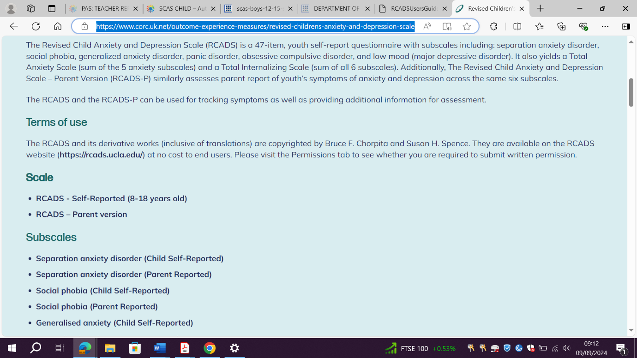

## Anxiety scale for children: autism spectrum condition (ASC-ASD) (key stages 3 and 4)

The ASC-ASD is a 24 item self-report questionnaire, with four subscales: separation anxiety, uncertainty, performance anxiety and anxious arousal, for use with young people aged 8 to 16 with a diagnosis of autism spectrum disorder (ASD).

The ASC-ASD was derived from the RCADS, which is a well-validated measure of anxiety developed for use with typically developing children. There are both child and parent versions of this questionnaire.

[Access a copy of the ASC-ASD here](https://research.ncl.ac.uk/neurodisability/leafletsandmeasures/anxietyscaleforchildren-asd/asc-asdchild/) (with translations available for Arabic, Chinese, Dutch, Filipino, French, Hindi, Icelandic, Kurdish, Norwegian, Persian, Polish, Sinhala, Spanish, and Tamil).

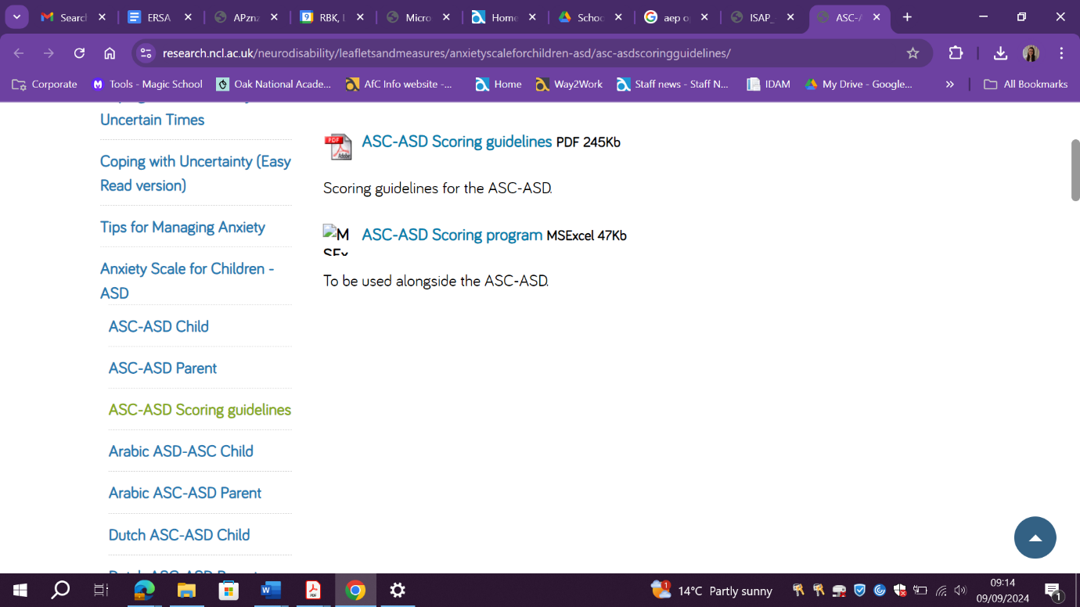Below is a screenshot that can help you understand what to expect on the website. You can find the ASC-ASD child and parent measures on the panel on the left-hand side of the website.

There is also a [scoring programme which helps with the interpretation of the scores](https://research.ncl.ac.uk/neurodisability/leafletsandmeasures/anxietyscaleforchildren-asd/asc-asdscoringguidelines/).

## Inventory of school attendance problems (ISAP) (key stages 3 and 4)

This questionnaire is about feelings and problems students can experience before or during school. Students are asked to select the response that best reflects their feelings, thoughts, and any problems they might be experiencing before or during school.

[An online version of the questionnaire can be found on the Insa Network website](https://insa.network/resources/questionnaires/). It also includes a built-in scoring system, which shows the results of various symptom levels.

Below is a screenshot that can help you understand what to expect on the website. On the left-hand side, there is a selection of feelings and problems, such as ‘I’m afraid to talk to other people’.

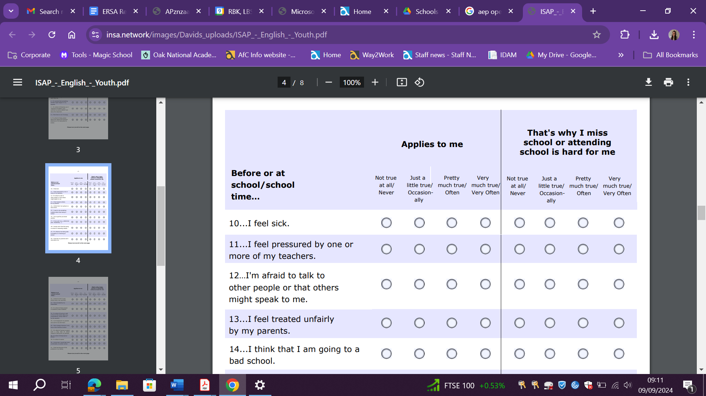

## Spence children’s anxiety scale (key stages 3 and 4)

This is a psychological questionnaire designed to identify symptoms of anxiety in children and young people aged 8 to 15. Answers are scored and then interpreted. The questionnaire takes around 10 minutes to complete and is available in various languages.

[The Spence Children's Anxiety Scale website](https://www.scaswebsite.com/portfolio/scas-child-download-scale/)

Below is a screenshot that can help you understand what to expect once you download the resource from the website. The screenshot of the document shows a selection of statements that are listed on the full version of the resource, such as ‘I feel afraid’ and ‘I worry about things’. These are statements that young people have to answer.

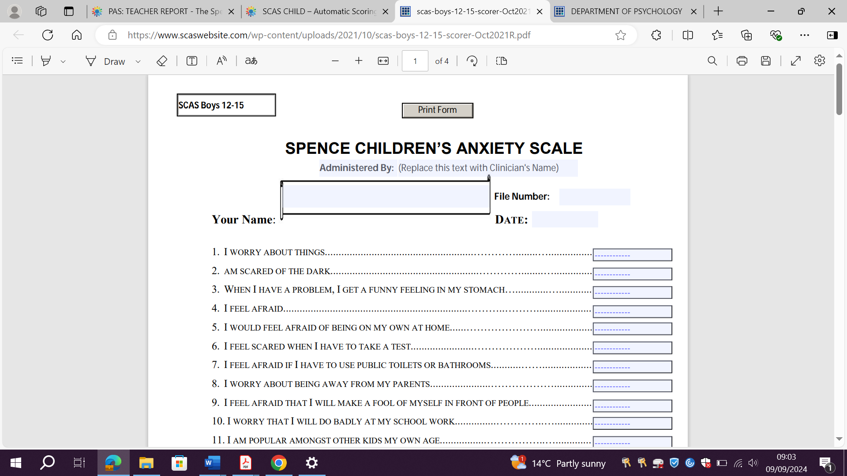

## Strengths and difficulties questionnaire (SDQ) (key stages 1 to 4)

The strengths and difficulties questionnaire is a brief behavioural screening questionnaire about 3 to 16 year olds, giving information on:

* emotional symptoms
* conduct problems
* hyperactivity and inattention
* peer relationship problems
* prosocial behaviour

It can be used as a pre and post intervention measure, and is available in various languages. [Information on scoring along with the questionnaires can be found on the SDQ website](https://www.sdqinfo.org/a0.html).

Below is a screenshot that can help you understand what to expect on the website. The screenshot highlights that the SDQ is a brief behavioural screening questionnaire that exists to meet the needs of researchers, clinicians and educators.

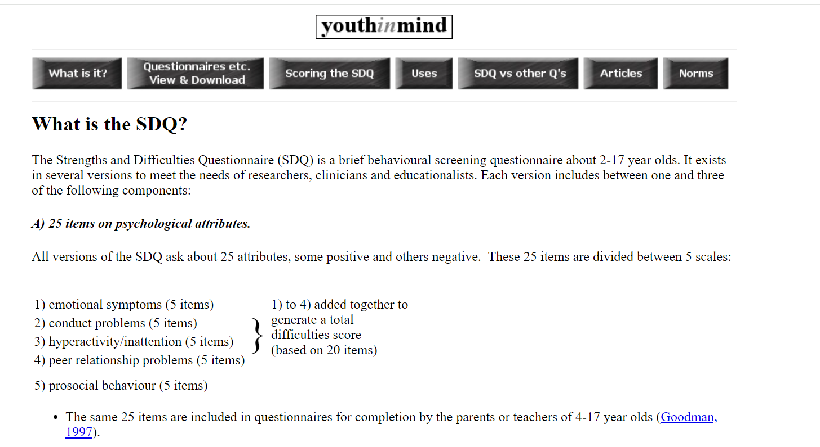

## Boxall profile (key stages 1 to 4)

The [Boxall profile](https://www.boxallprofile.org/) is a tool that allows professionals working with children and young people to assess and identify their levels of social and emotional skills or behavioural difficulties, and support them as necessary with the most appropriate interventions.

# Step 2. Assess the function of ERSA: gain the child’s views

These tools can be helpful in gaining the views of children. Children should be supported by a trusted adult in an environment that feels safe and supportive for them to complete one or more of these activities to gain their views.

## School stress survey (key stages 1 to 2)

### Administration instructions

The student should meet with a teacher, mentor, or teaching assistant they are familiar with. The member of staff goes through each picture item in the sequence and asks the student to rate themselves, by highlighting or putting a cross through the best-fitting answer.

For each item, the member of staff should also ask the child to explain their choice. The student is unlikely to find this easy. Questions such as ‘What happens during this part of the day?’, ‘What do you see?’ or ‘What do you hear?’ are more likely to elicit a response than ‘Why did you put this…?’. Make a note of any indicative words or phrases such as ‘teacher shouting’, ‘swearing’, ‘queueing up’, ‘too busy’ or others on the recording sheet.

At the end of the items, it may also be useful to ask students to undertake a similar rating activity with their timetable to identify any subjects or peer groups they may find stressful. These can also be noted on the recording sheet.

Finally, ask the student if there is anything else they find particularly easy and enjoyable or especially annoying or difficult about school. These can also be noted on the recording sheet.

### Scoring

The scoring below is not an exact science; it is based on averages and a ‘rule of thumb’ rather than standardisation.

|  |  |  |
| --- | --- | --- |
| **From 20 to 32** | **From 33 to 47** | **From 48 to 60** |
| High and regular stress levels. | Specific points of stress that may need further attention. Possibility the student is not expressing high stress levels. | Student appears to generally have low day-to-day stress levels in school. |

|  |  |  |
| --- | --- | --- |
| I very often or always feel stress at this. I can’t cope with it.Red sad face | I sometimes feel stress. I don’t like it, but I can cope. Amber neutral face | I feel OK about this. I can cope with this easily. Green happy face |

|  |  |  |  |
| --- | --- | --- | --- |
| Getting up and ready  Alarm Cartoon | Bus School Cartoon Journey to and from school | Assembly  Assembly Illustration | Corridors  Vector cartoon style school hallway with open doors of classes |
| Green happy faceAmber neutral faceRed sad face | Green happy faceAmber neutral faceRed sad face | Green happy faceAmber neutral faceRed sad face | Green happy faceAmber neutral faceRed sad face |
| Written work  Cartoon Writing | Break times  Kids playing at playground | Teacher question and answer  Student Asking Teacher | Team or group work  Children working in group in classroom |
| Green happy faceAmber neutral faceRed sad face | Green happy faceAmber neutral faceRed sad face | Green happy faceAmber neutral faceRed sad face | Green happy faceAmber neutral faceRed sad face |

|  |  |  |  |
| --- | --- | --- | --- |
| Lunchtimes  Lunch time | One-to-one with adults  Student Teacher | Tests  Test | Homework  Homework |
| Green happy faceAmber neutral faceRed sad face | Green happy faceAmber neutral faceRed sad face | Green happy faceAmber neutral faceRed sad face | Green happy faceAmber neutral faceRed sad face |
| Reading in front of class | Performances, for example: sports or drama  6,791 Kids Theatre Illustrations & Clip Art - iStock | Change of routine  Change in Routine and Change of Environment | New or different teacher  Teacher |
| Green happy faceAmber neutral faceRed sad face | Green happy faceAmber neutral faceRed sad face | Green happy faceAmber neutral faceRed sad face | Green happy faceAmber neutral faceRed sad face |
| Non-school uniform day  Blue School Uniform | Getting changed  Sport dressing room | School trips | New activities, for example: swimming  Swim cartoon |
| Green happy faceAmber neutral faceRed sad face | Green happy faceAmber neutral faceRed sad face | Green happy faceAmber neutral faceRed sad face | Green happy faceAmber neutral faceRed sad face |

|  |  |  |
| --- | --- | --- |
| **Item** | **Score**  **🙁 = 1 😐 = 2 🙂 = 3** | **Indicative words and phrases** |
| **Getting up and ready** |  |  |
| **Journey to and from school** |  |  |
| **Assemblies** |  |  |
| **Corridors** |  |  |
| **Written work** |  |  |
| **Break times** |  |  |
| **Teacher question and answer** |  |  |
| **Team or group work** |  |  |
| **Lunchtimes** |  |  |
| **One-to-one with adults** |  |  |
| **Tests** |  |  |
| **Homework** |  |  |
| **Reading in front of class** |  |  |
| **Performances** |  |  |
| **Change of routine** |  |  |
| **New or different teacher** |  |  |
| **Non-school uniform day** |  |  |
| **Getting changed** |  |  |
| **School trips** |  |  |
| **New activities, for example: swimming** |  |  |
| **Total score** |  |  |
| **Timetable issues** |  |  |
| **Other issues** |  |  |

## 

## Ideal school (key stages 3 and 4)

Ask the young person to think about the type of school they would like to go to. What would it be like? What would be there?

### Instructions

#### Part 1: Drawing the kind of school you would NOT like to go to.

#### Help the young person to make a sketch or talk to you about the type of school they would not want to go to by reading out these questions.

##### 1. The school

Think about the kind of school you would not like to go to. This is not a real school. Make a quick drawing of this school in the middle of the ‘school I would not like to go to’ box. Tell me three things about this school. What kind of school is this?

##### 2. The classroom

Think about the sort of classroom you would not like to be in. Make a quick drawing of this classroom in the school. Draw some of the things in this classroom.

##### 3. The pupils (other young people)

Think about some of the pupils at the school you would not like to go to. Make a quick drawing of some of these pupils. What are the children doing? Tell me three things about these pupils.

##### 4. The adults

Think about some of the adults at the school you would not like to go to. Make a quick drawing of some of the adults. What are the adults doing? Tell me three things about these adults.

##### 5. Me

Think about the kind of school you would not like to go to. Make a quick drawing of what you would be doing at this school. Tell me three things about the way you feel at this school.

**Part 2: Drawing the kind of school you would like to go to**

##### 6. The school

Think about the kind of school you would like to go to. This is not a real school. Make a quick drawing of this school in the middle of the ‘ideal school’ box. Tell me three things about this school. What kind of school is this?

##### 7. The classroom

Think about the sort of classroom you would like to be in. Make a quick drawing of this classroom at your ideal school. Draw some features of this classroom.

##### 8. The pupils (other young people)

Think about some of the pupils at the school you would like to go to. Make a quick drawing of some of these pupils. What are the children doing? Tell me three things about these pupils.

##### 9. The adults

Think about some of the adults at the school you would like to go to. Make a quick drawing of some of these adults. What are the adults doing? Tell me three things about these adults.

##### 10. Me

Think about the kind of school you would like to go to. Make a quick drawing of what you would be doing at this school. Tell me three things about the way you feel at this school.

**A school I would not like to go to:** 

**Ideal school:**

**How close is your real school to your ideal school? Circle a number below.**

**Not at all close Exactly the same**

|  |
| --- |
| **1 2 3 4 5 6 7 8 9 10** |

**What would help your real school be more like your ideal school?**

|  |
| --- |
|  |

**You may use the following options to help if you are stuck:**

Help with work

Help with friendships

Help at home

A quiet area in school

Help with my emotions

Help with bullying

To talk to someone

To know what is going to happen

More time

Help with social media

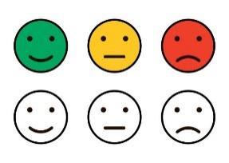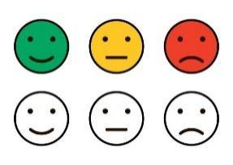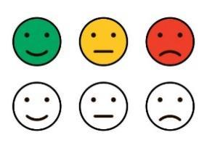

## Red, amber, green rating (key stages 1 and 2)

Using a timetable or a map of the school, the adults can work with the child or young person to use colours to identify times of the day or places in school that they can manage, can't manage, or may need some help managing.

## The incredible five-point scale and feelings thermometer (key stages 1 and 2)

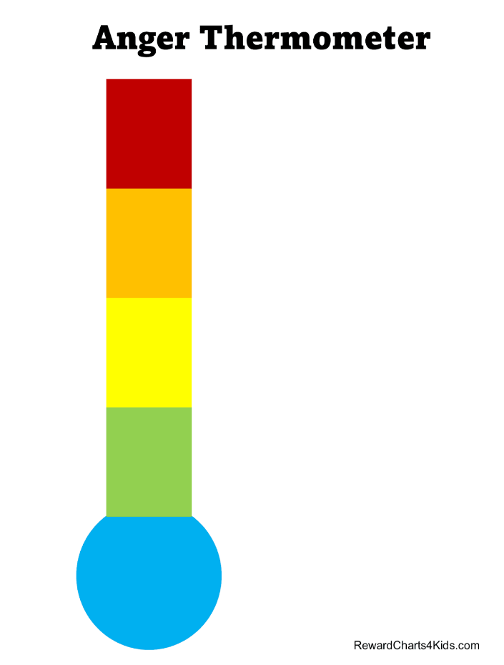

**Extremely breathless**

**Panic**

**Anxious**

**Tense   
Excited**

**Breathless**

**Alert/  
motivated**

**Calm**

**Breathing normally**

**100**

**75**

**50**

**25**

**0**

**Deep relaxation**

**Feelings Thermometer**

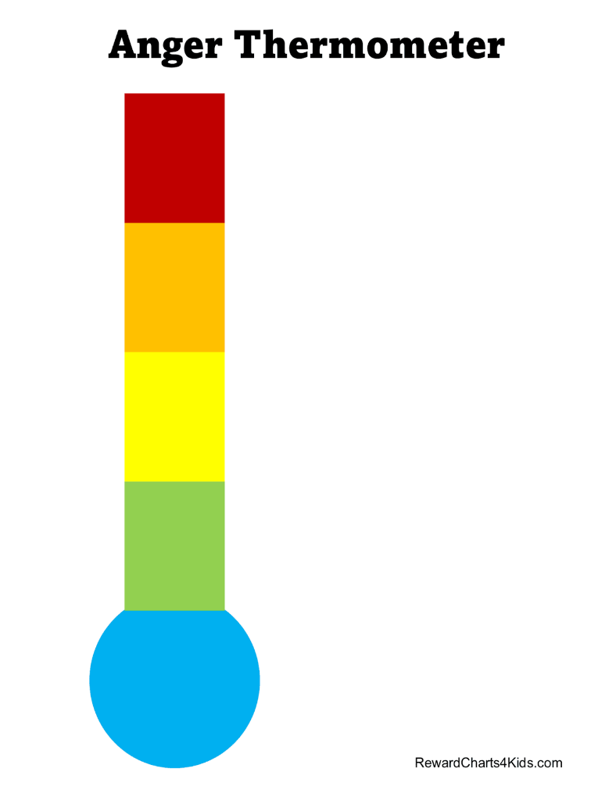

**Extremely breathless**

**Panic**

**Anxious**

**Tense   
and/or excited**

**Breathless**

**Alert or motivated**

**Calm**

**Breathing normally**

**100**

**75**

**50**

**25**

**0**

**Deep relaxation**

**Feelings thermometer**

The five-point scale, also known as a feelings thermometer, can be used as a way of supporting children and young people to understand and manage overwhelming feelings. It can be used with children and young people of all ages and begins with an exploration of emotions.

Children and young people can then use the scale to describe how they are feeling and what these feelings may look or sound like. With a trusted adult, children and young people can explore situations that may make them feel overwhelmed and move on to describing how to reduce overwhelming or difficult emotions as guided by the visual scale or thermometer.

The scales that children and young people make can be used as communication tools. For example, they can be turned into keyrings or bracelets using different coloured material to let adults know that they feel a certain way. There are free downloadable resources available on the [five-point scale website](https://www.5pointscale.com/).

## Classroom or school mapping (key stages 1 to 4)

This involves a child or young person drawing, describing, or building a model to demonstrate their ideal classroom or school. This can be creative and involve the young person colouring in areas of the class that make them happy or make them feel stressed. It could be a drawing that represents the ideal characteristics of a classroom.

The following resources from Cambridgeshire County Council may help in understanding a child or young person’s perspective on school, including both the physical and social environment.

* [Primary aged resources for school mapping](https://www.cambslearntogether.co.uk/asset-library/your-feelings-about-school-primary1.pdf)
* [Secondary aged resources for school mapping](https://www.cambslearntogether.co.uk/asset-library/your-feelings-about-school-secondary1.pdf)

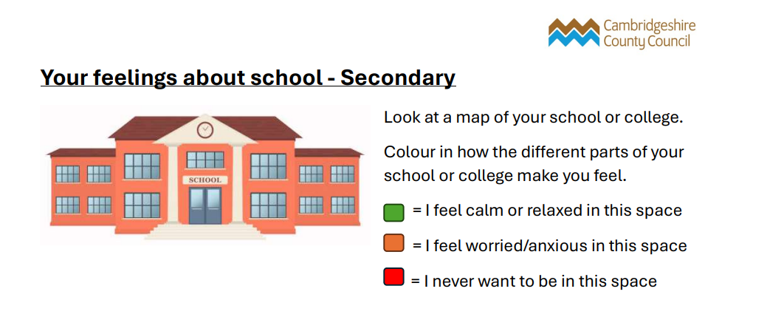One of the secondary aged tools asks young people to look at a map of their school or college. It then asks them to colour in how the different parts of the school or college space make them feel. Green is for calm, amber for feeling anxious and red for not wanting to be in that space. The below screenshot from Cambridgeshire County Council showcases these instructions.

## Card sorting activities (key stages 1 to 4)

These card sorting activities have been created to help gather the views of children and young people about their educational experience and current situation.

The activities should be carried out by an adult with whom the child has a positive and secure relationship. It is important that enough time has been set aside to complete these activities. It is possible that discussing some of these sensitive areas can lead the child to experience distress, so there needs to be freedom to extend the session if required.

It is important that it is not just viewed as an activity to be ticked off; if there are any areas that need exploring further, this should take place. Adults should also ask questions to gain richer information. For example if a question asks about friends or teachers, ask the children and young people which specific teacher or friend they are thinking of. It’s also recommended to ask why they have placed a particular card under a specific heading. The record forms included can be used to mark the children’s and young people’s responses during the activity. The adult should also note down any comments and discussions that take place.

Once completed, the information should be considered to identify areas of need, strengths, and the most appropriate support. The children and young people should also be asked if they have any ideas what might make things better or easier. For example, if they place ‘maths’ under angry, ask if there is anything that would make them move ‘maths’ to ‘happy’. It is important that any views are shared sensitively with parents and carers, so the support agreed is consistent across different contexts, and outcomes can be worked towards collaboratively.

### Card sorting: likes and dislikes and how this makes me feel (key stages 1 and 2)

How to use this resource:

The picture cards serve as a guide to help children express their thoughts and feelings about specific aspects of school (for example: spelling, maths, and friendship). You can ask them to sort the cards into different categories, such as ‘easy, ok, hard’ or ‘happy, sad, angry’, as shown below. You may wish to print out the category headers and arrange them in a way that makes it easy for children to sort the picture cards accordingly.

It might be helpful to pre-select some picture cards for the child you are working with.

[Online version of the like and dislike cards](https://www.flippity.net/ma.php?k=1-uevzgFdTlOwxvO8lM9kMDcFmm8Kglt5BEFTrNZfyXM).

|  |  |
| --- | --- |
| **Happy face**  Happy | Green happy face  Easy |
| **Sad face**  Sad | Amber neutral face  OK |
| Angry Face  Angry | Red sad face  Hard |

|  |  |  |  |
| --- | --- | --- | --- |
| A pencil writing a letter  **Spelling** | A cartoon of a worm reading a book  **Reading** | A drawing of letters and a pencil  **Writing** | A drawing of a letter A and an ant for phonics  **Phonics** |
| A group of colorful symbols  **Maths** | A close-up of a logo  **English** | A drawing of a couple of beakers  **Science** | Sports  **P.E.** |
| A drawing of a book and a sword  **History** | A blue and green planet  **Geography** | A drawing of a computer  **IT** | A paintbrushes and a paint palette  **Art** |
| A drawing of a guitar and notes  **Music** | A group of flags and words  **Languages** | A drawing of a DNA strand and a cell  **Biology** | A drawing of a chemistry experiment  **Chemistry** |
| A drawing of masks w  **Drama** | Technology  **Technology** | PSHE  **PSHE** | Interventions  **Interventions** |
| Assembly  **Assemblies** | Form Time  **Form time** | School  **School** | Home  **Home** |
| Breakfast Club  **Breakfast club** | After-school club  **After school club** | Friends  **Friends** | Teacher(s)  **Teacher(s)** |
| Talking  **Talking** | Reading out loud  **Reading out loud** | Answering Questions  **Answering questions** | Free Time  **Free time** |

## Environmental factors and functions of behaviour (key stages 3 to 4)

### How to use this resource:

This resource is intended to gather the young person’s views on their behaviours as well as the factors in the school environment.

* Kindly refer to **pages 3 to 11** in [this 'cards to explore behaviour' document developed by Cambridgeshire County Council](https://www.cambslearntogether.co.uk/asset-library/pupil-views-cards1.pdf)
* You may want to print the cards out on A3 paper and consider laminating them for repeated use
* Cut out the individual cards

Then:

* Cut (or draw) out the scale for environmental school factors and functions of behaviour (as shown below). You may choose to use both scales in any order you find appropriate, or just one of them.
* Ask the child to rank each card

### The scales and examples

* **For the environmental school factors scale**, ask the child to rank each card against what is ‘least important’ to ‘most important’.
* **For the functions of behaviour scale**, ask the child to rank each card against what is ‘least like me’ to ‘most like me’.

##### Environmental school factors

Two examples of environmental factor cards, namely ‘less noisy’ and ‘less busy’ are shown below. For a full range of environmental factor cards, please see the Cambridgeshire County Council resource.

**Environmental school factors**

**Least important**

**Most important**

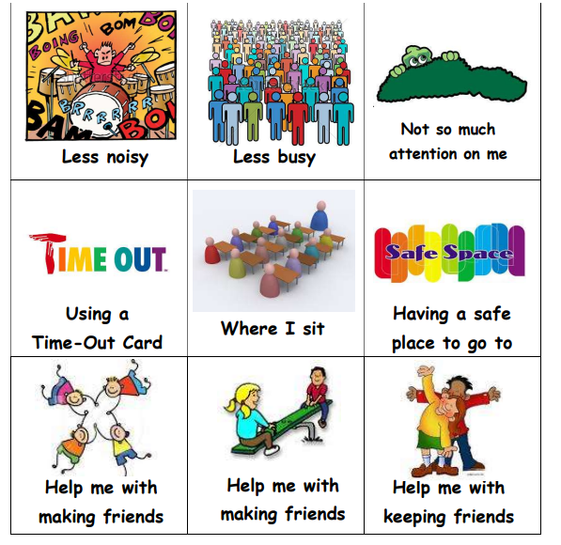

##### Functions of behaviour

Two examples of functions of behaviour cards, namely ‘I don’t want to be noticed’ and ‘I want to be liked by other kids’, are shown below. For a full range of cards describing the functions of behaviour, please see the Cambridgeshire County Council resource.

**Functions of behaviours**

**Least like me**

**Most like me**

**A bit like me**

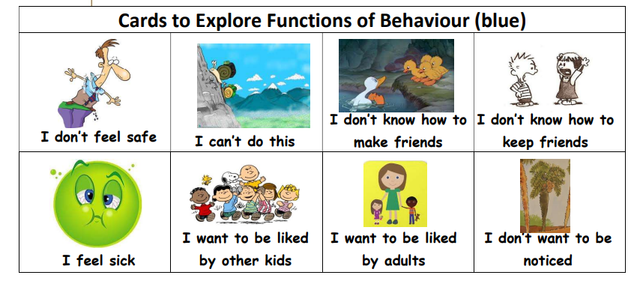

## Function of school avoidance (key stages 1 to 4)

**Blue (function 1):** To avoid something or situations that elicit negative feelings or high levels of stress or anxiety (for example: fear of the toilets, the noise in the playground, lots of people moving all together in the corridors between classes, tests or exams)

**Red (function 2):** To escape difficult social situations (for example: feeling left out at playtime, reading out loud in class or a different public speaking task, or working as part of a group)

**Green (function 3):** To get attention from or spend more time with significant others at home (for example, change in family dynamic or concern about the wellbeing of parent)

**Yellow (function 4):** To spend more time out of school as it is more fun or stimulating (such as watching TV, going shopping, playing computer games, or hanging out with friends)

This card sorting activity, based on a ‘School Refusal Assessment Scale’ developed by Kearney (2002), has been devised by the Sheffield Educational Psychology Service as a tool to support staff to develop a greater understanding of a young person’s school avoidance. The 24 statements are colour-coded by the function of behaviour identified by Kearney and Silverman (1990). By asking a child or young person to sort the statements or by talking about each one, mentors may find that using the cards can support an understanding of the function of the school avoidance behaviour.

### How the statements could be used with a child

* Cut up the statements
* Ask the child to sort the statements into the three groups shown on the white cards on page 31: a bit like me, most like me and least like me
* Referencing the colour codes on each card, consider if any patterns are noticeable and whether some functions are more prevalent than others
* If the child or young person is comfortable, discuss the statements to help build a richer picture

Consider together how this information can help to plan the next steps.

[Online version of 'function of school avoidance' tool](https://www.flippity.net/ma.php?k=1pBWu5IHxnvVQXc8nPFdsWSHnFH9Q3T2dxAQdSPCXgQo)

I stay away from school because   
it is hard to speak with the other kids at school.

I have bad feelings about going to school because I am afraid of something related to school (for example: tests, the school bus, teacher(s), or the fire alarm).

When I am not in school during the week (Monday to Friday), I leave the house and do something fun.

I would rather be with my parent(s) than go to school.

I stay away from school because I will feel sad or depressed if I go.

I stay away from school because I feel embarrassed in front of other people at school.

I think about my parents or family when in school.

When I am not in school during the week (Monday to Friday), I talk to or see other people (other than my family).

If it were easier for me to make new friends, it would be easier for me to go to school.

If I had less bad feelings (for example, scared, nervous or sad) about school, it would be easier for me to go to school.

It would be easier for me to go to school if my parents went with me.

It would be easier for me to go   
to school if I could do more of the things I like to do after school hours (for example, being with friends).

I often stay away from people in school compared to other kids of my age.

I have bad feelings about school (for example, scared, nervous or sad) compared to other kids of my age.

I would like to be home with my parents more than other kids my age would.

I would rather be doing fun things outside of school more than most kids of my age would.

I stay away from school because  
 I do not have many friends there.

I feel worse at school (for example, scared, nervous or sad) compared to how I feel at home.

I would rather be with my family than go to school.

When I am not in school during the week (Monday to Friday), I enjoy doing different things (for example, being with friends or going places).

I have bad feelings about school (for example, scared, nervous or sad) when I think about school on Saturday and Sunday.

I stay away from places in school (for example, hallways, places where certain groups of people are or where I would have to talk to someone).

I would rather be taught by my parents at home than by my teacher at school.

I stay away from school because I want to have fun outside of school.

Most like me

A bit like me

Least like me

## Sentence starter cards (key stages 1 and 2)

### How to use this resource:

* Print this page and cut out the sentence starter cards
* Select a card or ask the child to select a card
* Ask the child to complete the sentence, either verbally or using drawings
* If the child or young person is comfortable, discuss their sentences to help build a richer picture

|  |  |
| --- | --- |
| **Thumbs up representing something good about schoolThe best thing about school is _______** | **The worst thing about school is ______**  **Thumbs down representing something bad about school** |
| **I am good at _____________**  **Tick representing something I am good at** | **I am not good at __________**  **A cross representing something I am not good at** |
| **I feel happy when _______Happy face** | **I feel sad when _______Sad face** |
| **When I do something well I think ________**  **Thought bubble** | **When I make a mistake I think ________**  **Thought bubble** |
| **I feel angry when ________**  **Angry face** | **I feel calm when ______**  **Happy and calm face** |
| **Children in my class think that I’m______**  **Thought bubble** | **My teacher thinks that I’m______**  **Thought bubble** |

## Return to school planning (key stages 1 to 4)

The return to school planning tool has been designed by West Sussex Educational Psychology Service to help schools, parents and relevant professionals gain greater insight into the experiences of young people who have been at home due to emotionally based school avoidance (EBSA), as well as their thoughts and feelings around preparing for a return to school. It also aims to encourage young people to experience more control over their reintegration, which we know helps young people feel safer.

This tool is intended to provide information to guide the school and parents in designing a reintegration plan, where support is targeted and tailored to the child’s or young person’s own experiences, views and preferences.

* [Return to school planning tool for younger students](https://schools.westsussex.gov.uk/Pages/Download/35bbded9-7220-41e1-8930-c2778bc5beaf/PageSectionDocuments)
* [Return to school planning tool for older students](https://schools.westsussex.gov.uk/Pages/Download/35bbded9-7220-41e1-8930-c2778bc5beaf/PageSectionDocuments)

There are several different sections in the return to school planning tool.

* **Section 1: All about me:** gathering information about a young person’s interests, likes and what they find important.
* **Section 2: Staying at home:** understanding the young person’s experience of being at home while not attending school.
* **Section 3: Going back to school:** understanding the young person’s feelings around returning to school.
* **Section 4: My coping toolkit:** developing a range of coping strategies with the young person.

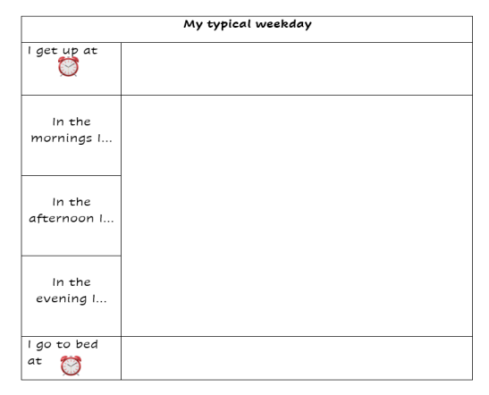

# Step 3. Plan the changes that need to be made: completion of the support plan and gaining the child’s views about what could help

## Card sorting: areas of support (key stages 1 and 2)

You may print these cards out and get the child to sort them according to the three categories below.

[Online version of the 'areas of support' cards](https://www.flippity.net/ma.php?k=1eKBTUaiHSg7nCZri6zJRPxaB1zpMcaYiC0aVnay5HjI).

|  |
| --- |
| **I don’t need…** |
| **Sometimes**  **I need…** |
| **Lots of times/ often I need…** |

|  |  |  |  |
| --- | --- | --- | --- |
| A drawing of a hourglass  **Time** | A yellow cartoon character with a finger on mouth  **Quiet** | Person needing help  **Help with my work** | Help with my friends  **Help with my friends** |
| Help with my emotions  **Help with my emotions** | Adults to listen  **Adults to listen** | Friends to listen  **Friends to listen** | Instructions repeated  **Instructions repeated** |
| A drawing of a milk carton and an apple  **Help with food** | A drawing of a shirt skirt and socks school uniform | A drawing of a book and a pencil  **Equipment for school** | A drawing of a bed  **Help getting up in the morning** |
| Help at home  **Help at home** | Sitting near friends  **Help with my uniform**  **To sit near my friends** | A quiet place  **A quiet place to go** | Harder work to do  **Harder work to do** |

|  |  |  |  |
| --- | --- | --- | --- |
| Worries  **To talk about my worries** | Future  **To know what is going to happen** | Classroom  **To know who will be in the classroom** | Easier work to do  **Easier work to do** |
| Someone to talk to  **Someone to talk to** | More time with my parents  **More time with my parents** | Social media icons  **Help with social media** | Bullying  **Help with bullying** |
| Someone to make me feel safe  **Someone to make me feel safe** |

## Card sorting: responding to difficulties (key stages 3 and 4)

This resource is intended to gather the young person’s views on their behaviours as well as factors in the school environment.

### How to use this resource:

* Kindly refer to pages 12 to 17 in [this 'Cards for Strategies' document developed by Cambridgeshire County Council](https://www.cambslearntogether.co.uk/asset-library/pupil-views-cards1.pdf)
* You may want to print them on A3 paper and consider laminating them for repeated use
* Cut out the individual cards
* Cut (or draw) out the scale for responding to difficulties below

Then:

* Ask the child to rank each card from what is ‘least helpful’ to ‘most helpful’

### The responding to difficulties scale

* Two examples of responding to difficulties cards, namely ‘Use a calm voice’ and ‘Ask me to smile’, are shown below. For a full range of cards describing ways to respond to difficulties, please see the Cambridgeshire County Council resource.

**Responding to difficulties**

**Most helpful**

**Least helpful**

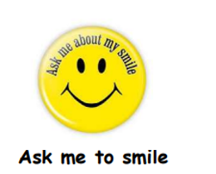

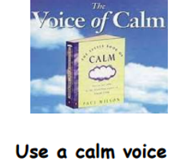

## 

## Ladder hierarchy (key stages 3 and 4)

1. Draw a ladder (or use a special interest of the child, for example a trophy if they love football).
2. On the top rung of the ladder, ask the child to write the final step that they want to achieve. This will differ depending on the child, it may be a full week in school, a full day, a full lesson or going into the lunch hall.
3. On the bottom rung of the ladder, ask the child to write the first thing that they want to do to face their anxiety. This needs to be an action that is currently in reach.
4. Put other steps on the rungs, gradually building up to reach the top rung.
5. Ensure steps are small and achievable.
6. Start to carry out the action on the first step.
7. The young person should measure their anxiety on a scale of 1 to 10 or 1 to 100, with 10 or 100 being the most anxiety-provoking situation.
8. Move on to the next rung when they feel ready.
9. The young person should reward themselves for achieving each step.
10. If one step seems unachievable, the young person should think about how they could break it down further and smaller, and into more manageable steps. It is important to work with the young person to think about what coping technique (for example, thinking, grounding, relaxation or distraction) they will use as they work through the rungs on the ladder, and what support will be in place for them at school.

## ERSA support plan (option 1)

## (key stages 1 to 4)

The ERSA support plan is a tool and intervention to help schools, parents, carers, and the child or young person identify achievable goals. These goals will help the child or young person move towards greater school attendance and engagement in education, and will include the necessary provisions and key stakeholders required for support. The ERSA support plan should be completed alongside the child or young person and a trusted adult to ensure that the goals and support are agreed upon by all parties involved, and that the child’s or young person’s voice is heard. The child or young person may be able to provide valuable information to create a successful ERSA support plan, including examples of support that has previously helped, steps towards goals that feel manageable for them, and key people they want to support them.

The ERSA support plan should be reviewed at regular intervals to track progress and amend if necessary.

## ERSA PCPath (option 2) (key stages 1 to 4)

The PCPath is a tool you can use to support a child or young person with ERSA towards a specific goal or dream for the future, to work out the actions that need to be taken to make that happen, or when a situation would benefit from group planning and focusing on the future.

When using the PCPath, a group of people chosen by the child or young person along with the child or young person themselves, or just the child or young person individually, work alongside a facilitator to use the PCPath template. They will develop achievable and realistic goals for the future based on ‘the dream’ and implement backwards planning to create a step-by-step path to reaching that goal.

It has a very clear structure and commits to tasks within a given timescale, while always maintaining focus on the hopes and goals of the child or young person.

## How to use it

Using a very large sheet of paper with the PCPath template drawn on it, the group and/or young person is guided by the facilitator through the process, and the plan is recorded in words and pictures.

* Firstly, they look at the young person’s dreams. No limits or constraints are placed on the dreams or the ideal future that they illuminate, allowing the young person to express what matters most to them. Based on these dreams and the young person’s vision for the future, specific goals that are positive and possible are identified.
* Next, they imagine possible and positive achievements and goals that could be reached over the next one to two years.
* This is then compared to how the young person’s life is ‘now’, with current strengths identified. The skills that need to be developed or what needs to be put in place to help reach the one to two year goals are highlighted.
* Finally, the next steps needed to achieve the goals are planned, along with identifying the people who can help the young person reach their goals, and what they need to do to stay strong and motivated. For some examples, please refer to the ERSA support strategies.

A key to this planning process lies in identifying who will be responsible for what in helping the child or young person achieve their goals. This allows the child or young person, family members, other community members, and school staff to make specific commitments to take action. Usually, opportunities to review the young person’s goals and update actions are provided.

Both templates may be found in the document titled ‘[ERSA support plan](https://rbwm.afcinfo.org.uk/pages/community-information/information-and-advice/schools-and-education/educational-support-services/emotionally-related-school-avoidance-ersa)’. The document also includes examples of strategies for an ERSA support plan.

# Step 4. Review (prompt questions and example)

At an agreed date, conduct a review meeting to go through the support plan and how it has been supporting the young person so far. Where possible (for example, with secondary aged students), the young person should be involved in the meeting and should have a choice of who they want to attend the meeting. It is important that the goals and targets for the young person are not changed before the date of the review meeting.

Questions that could be asked during the review include:

* What is working well?
* What needs to change?
* What are the next steps?