

**Attendance strategy document**

For AfC staff working with young people from

Royal Borough of Windsor and Maidenhead

June 2024

**Version control**

Applies to Schools, partners, AfC wide and committee

members

Review Board Education Welfare Service

Signed off by Clive Haines Deputy Director for Education

Reviewing arrangements This policy will be reviewed every three years to

judge its effectiveness, or updated sooner in accordance with changes in legislation

Date policy first created June 2023

Current version date June 2024

Next review date June 2026

Equality analysis completed N/A

Relating policies and procedures N/A

Version Version 1 June 2023

**Table of contents**

**Overview 4**

Who is it for? 4

Why is good attendance important? 4

**Local context 5**

**Implementing the policy 6**

What are our key challenges? 6

What are we going to do? 6

Who is going to help us? 7

How are we going to do this? 7

The graduated response 8

The role of parents and carers 8

The role of schools in embedding a whole - school approach 9

The role of the local authority 10

What are the local authorities' responsibilities? 10

**Monitoring and reviewing 11**

How will we know we have succeeded? 11

**Relating policies and procedures, appendices and further reading 12**

**Overview**

This Attendance Strategy has been implemented to sit alongside the ‘Working together to improve school attendance guidance: applies from 19th August 2024’ published by the Department for Education (DfE) in February 2024 and Statutory from 19th August 2024

**The government sees reducing absence as a priority and has emphasised that attendance is everyone’s business and a key aim is making it a major focus within the Ofsted (safeguarding) agenda.**

**Who is it for?**

* All school and academy trust staff, including headteachers, governors, academy trustees, and alternative provision providers.
* Local authority attendance staff, early help lead practitioners, social workers, and virtual school heads.
* Statutory safeguarding (including police and integrated care boards) and other local partners

**Why is good attendance important?**

There is a wide range of international evidence that tells us that children who attend school regularly go on to achieve better outcomes, live healthier, wealthier and more enriched lives - and we want to make sure we are all doing everything that we can to make that happen for all of our children.

Children are best supported by those who already have a relationship with them, such as schools, who can organise additional support with local partners as needed. The expertise of our schools and a wide range of agencies including the voluntary and community sector is invaluable. We all have high aspirations for the children and young people in Maidenhead, Windsor and Ascot. We want them to enjoy life in the borough and beyond, to achieve well, and to thrive as part of a strong and inclusive community and economy. Good attendance at school is vital if they are to realise this ambition and reach their full potential.

The barriers to accessing education are wide and complex, both within and beyond the school gates, and are often specific to individual pupils and families. The foundation of securing good attendance is that school is a calm, orderly, safe, and supportive environment where all pupils want to join and are keen and ready to learn. Some pupils find it harder than others to attend school and therefore at all stages of improving attendance, schools and partners should work with pupils and parents to remove any barriers to attendance by **building strong and trusting relationships and working together** to put the right support in place.

School is not just about academic success and attainment. It is also centered on learning about the world, about relationships and about individuals. It is about trying new things, making new friends, and finding a place in the world. To miss school is to miss the multifaceted experiences that shape the choices we make, the opportunities we have and the quality of life that we lead.

Attendance is also an important protective factor and the best opportunity for children’s needs to be identified and support provided. Research has shown associations between regular absence from school and a number of extra-familial harms.

**Local context**

It is true that the vast majority of children in Windsor, Maidenhead and Ascot have excellent attendance records. There are examples of outstanding practice, rooted in strong partnership arrangements, happening every day in our schools and we learn from that. Poor attendance at school can hinder emotional health and wellbeing. Children and young people who miss school on a regular basis, can become socially isolated; they can lack confidence and may have low self-esteem. Young people who regularly miss school are at greater risk of anti-social behaviour and are more likely to become victims of crime. These experiences are not the life outcomes we want for our children.

Whilst there has been no reliable data collections available since 2018/19, we have continued to work to achieve high standards of education and achieve good attendance levels for all our children. The ‘working together guidance’ emphasises the need for schools, local authorities and the wider partnerships to have a **shared responsibility** to improve outcomes for all children attending school.

There are a total of 66 schools in RBWM of which 28 are state maintained schools, 28 academies, 5 free schools and one alternative provision; RISE. Both special schools (Manor Green and Forest Bridge) are maintained schools. As of June 2024 92% of schools in RBWM are Good to Outstanding

**2022/2023 absence data;**

**Implementing the policy  
What are our key challenges?**

There are many reasons pupils can be absent and they fit into four broad categories: barriers, negative school experiences, lack of engagement and misconceptions. Reid (2005), places the types of absentees into three categories:

**Traditional** - Health. difficulties engaging with families

**Psychological** - Social emotional mental health (SEMH) challenges  
**Institutional** - Negative experience in the school environment

**What are we going to do?**

Our attendance strategy covers the next three academic years, from 2024 to 2027, and this will assist in refining our approach to school attendance over that time. This strategy will ensure our local approach is not only in line with current government guidance and legislation, but that it recognises the needs across all of our school community, post pandemic and during the cost of living crisis, and seeks to support them.

Our main priorities are to:

* have up-to-date knowledge of borough attendance trends and also individual pupil attendance data
* develop a clear understanding of the roles and responsibilities for the professional network, including the graduated response to supporting presenting needs
* deliver effective training/support for all stakeholders on key issues



**Who is going to help us?**

If we are to achieve our priorities we all need to work together. Any of the following stakeholders could be a lead professional and/or a key partners in tackling poor attendance:

* Young People themselves
* Parents and carers
* Attendance Lead on Senior Leadership within school
* Alternative Education providers
* Health Services; including School Nurses and CAMHS
* Careers Support and Post 16 providers
* Children’s Social Care and The Virtual School
* SEN officers and Case Coordinators
* Early Help and Family Hub Workers
* YOS Education Officers
* Early Years SEN
* Education Psychology Service
* Education Welfare Officers
* Legal Support
* Department for Education
* Voluntary and Faith Sector
* Mental Health Support Teams
* School Family Support Workers
* SEMH Coach Mentors
* Pastoral Support within schools

**How are we going to do this?**

* Further develop our borough wide culture related to promoting strong attendance across all services and stakeholders
* Encourage the consistent use of supportive policies, systems and processes for the professional network to adopt to bring a consistent approach to promoting strong school attendance
* Ensuring the professional network understands the importance of strong school attendance through a programme of effective communication, training and professional development
* Applying systems of identifying pupils who need support and applying evidence based targeted interventions for the professional network to use to improve school attendance
* Continue to ensure ERSA is recognised, supported and receives targeted support through the Toolkit, Attendance Network and Educational Psychology team.
* Continue to have dedicated staff to coordinate and support those children that are Electively Home Educated and those Children Missing Education
* Specifically monitor and co-ordinate support regarding the attendance of those children with an EHCP
* Co-create and support the Virtual School with a Specialist EWO for Children with a Social Worker

**The graduated response**

The graduated approach is a framework of staged interventions. Interventions begin with effective whole-school approaches to managing the attendance of all children. School policies should promote good attendance, make clear what everyone’s roles and responsibilities are and clearly outline what action is taken at each stage so that early intervention can take place. An effective whole-school approach will include regular monitoring and reviewing of practice. Rapid and efficient early intervention will help prevent long term absence from school.

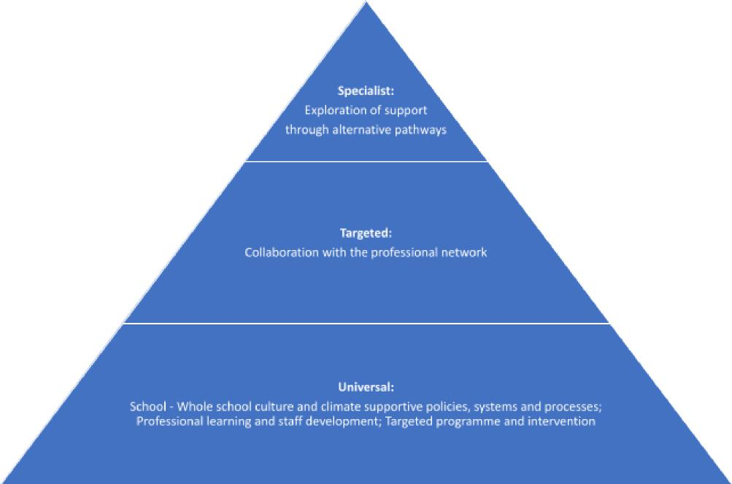

**The role of parents and carers**

Parents and carers are responsible for ensuring their child is in receipt of education as outlined under the Education Act 1996 Section 7. This can be either by attendance at school or choosing to electively home educate them.

Where a child is on roll at a school, parents have a duty to ensure their child attends regularly. Parents and carers are expected to report their child’s absence from school on the first day of absence.

Where there are concerns about a pupil’s attendance, parents and carers are expected to work with school staff and other services to address them. Parents and carers are expected to support school attendance by avoiding family holidays during term time. Parents and carers are also responsible for following any related Public Health England (PHE) guidance and are required to inform schools of any infectious illnesses.

**Parents and carers are expected to:**

* encourage and ensure that their children attend school regularly and punctually unless there is a valid reason for absence which is accepted by the school’s headteacher
* comply with their roles and responsibilities as outlined in the school attendance policy
* intervene promptly and work closely with the school and local authority to resolve any issues when attendance problems occur
* avoid term time holidays - a term time holiday may mean a pupil becomes a persistent absentee if they go on to have any further time away from school

**The Role of Schools in embedding a whole - school approach**

Schools are expected to have a clear school attendance policy on their website which all staff, pupils and parents understand (this is likely to require ongoing reflection and development in line with government guidance). The policy should be clear about what actions are to be taken if a pupil’s attendance or punctuality becomes a cause for concern and the processes that are in place to address this. The new ‘working together to improve school attendance’ statutory guidance reinforces that improving attendance is everyone's business [[Working together to improve school attendance - GOV.UK](https://assets.publishing.service.gov.uk/media/65f1b048133c22b8eecd38f7/Working_together_to_improve_school_attendance__applies_from_19_August_2024_.pdf)](https://assets.publishing.service.gov.uk/media/65f1b048133c22b8eecd38f7/Working_together_to_improve_school_attendance__applies_from_19_August_2024_.pdf)

Key expectations of schools are that they:

* are developing and maintaining a whole school culture that promotes the benefits of high attendance working alongside the DFE guidance and the Education Welfare Service
* accurately complete admission and attendance registers
* have robust daily processes to follow up absence
* have a dedicated senior leader with overall responsibility for championing and improving attendance
* submit attendance data to the DfE
* proactively use data to identify pupils who are at risk of poor attendance
* regularly analyse attendance and absence data to identify pupils or cohorts that require support with their attendance and put effective strategies in place (informed by the type of the absence - traditional, psychological or institutional)
* work with each identified pupil and their parents to understand and address the reasons for absence (in particular the type of absence: traditional, psychological and institutional), including any in-school barriers to attendance
* where out of school barriers are identified, signpost and support access to any required services in the first instance
* continued support for pupils at risk of becoming persistently absent and where there is a lack of engagement, hold more formal conversations with parents and be clear about the potential need for legal intervention in future
* where support is not working, are engaged with or appropriate, work with the local authority on legal intervention
* where there are safeguarding concerns, refer the matter to MASH/SPA
* identifying pupils who are regularly missing school and become children missing their education (being aware of the reporting process to the local authority and comply)
* consider additional support from wider services and external partners, making timely referrals, so as to provide support for persistently absent pupils
* agree a joint approach for all severely absent identified as those missing more than 50% percent of school
* where the school has exhausted all of their strategies, they would seek advice and support from the professional network

In addition to the above, schools should:

* ensure school leaders fulfil expectations and statutory duties
* ensure effective communication between school staff supporting vulnerable pupils
* ensure school staff receive adequate training on attendance
* identify pupils with medical conditions or special educational needs and disabilities
* understand the use of part-time (reintegration) timetables and alternative arrangements that are available to support good attendance (please see the reduced timetable guidance or protocol via the [Education Leadership Update Website/EWS](https://www.leadershipupdate-rbwm.co.uk/education-welfare-service-202425/) link)
* share knowledge and work collaboratively with other schools in the area around attendance strategies
* work alongside the local authority and other partners when absence is at risk of becoming persistent or severe.
* put in place additional support and adjustments, such as an individual healthcare plan and if applicable, ensuring the provision outlined in the pupil’s education, health and care plan (EHCP) is accessed

[Improving attendance: good practice for schools and multi-academy trusts - Case study - GOV.UK](https://www.gov.uk/government/case-studies/improving-attendance-good-practice-for-schools-and-multi-academy-trusts)

**The role of the local authority**

The ‘Working Together to Improve School Attendance’ Feb 2024, emphasises the role of collaborative working across schools and in the local authority to ensure we act as champions of children and parents, ensuring that the school system works for every family. The role of the local authority therefore is:

* to devise a clear strategic approach to recognising the importance of attendance and focus its efforts to unblock area wide barriers to attendance
* to work jointly with all local partners to ensure a multi-agency approach to supporting pupils who need it, acting as a lead practitioner where it is identified the best placed service is a local authority one.
* to ensure staff are appropriately trained in understanding about school attendance as to ensure we foster a collaborative culture across early help services
* to build an effective data sharing arrangements with different partners to further support the strategic plan
* make use of local attendance data to set a clear vision for improving attendance across the geographical area, with short and longer term aims and priorities for improving attendance for particular cohorts of pupils identified. This should include benchmarking against both geographical and demographic neighbouring local authorities, along with regional and national averages to ensure the roles of the professional network are understood and consistently implemented (with an effective training programme in place to support this)

**What are the local authorities' responsibilities?**

By law, all children aged between 5 and 16 must receive an education. Once a child is registered at a school, it is the parents’ legal duty under the Education Act 1996 to ensure that the child attends school regularly and punctually.

There is a statutory duty on all local authorities, under the Education Act 1996 working in partnership with schools and partner agencies to promote the right for all children to access education when they become compulsory school age at 5 up to 16 (up to 25 for those with EHCPs) through securing access to education. For the majority of children and young people they attend school.

Children and young people will not achieve as well as they should at school if they do not attend regularly. They are also likely to be disadvantaged as a result both educationally and socially. Not only are their own prospects damaged but sometimes the wider community is affected as well. Evidence has shown that truants are more likely to become involved in anti-social behaviour or crime either as perpetrators or as victims. Poor attendance at school adversely affects future employment prospects. Those children that are persistently and severly absent from school are also more vulnerable to abuse and being exposed to the risks of drug or substance abuse.

**Monitoring and reviewing**

**How will we know we have succeeded?**

Monitoring and evaluation. Progress in relation to the Attendance Strategy will be reviewed on an annual basis. We would expect to see overall absence percentages fall in comparison to previous years.

**Relating policies and procedures, appendices and further reading**

* [Working together to improve school attendance - GOV.UK](https://assets.publishing.service.gov.uk/media/65f1b048133c22b8eecd38f7/Working_together_to_improve_school_attendance__applies_from_19_August_2024_.pdf)
* [Children Missing Education Statutory Guidance for Local Authorities September 2016](https://assets.publishing.service.gov.uk/government/uploads/system/uploads/attachment_data/file/550416/Children_Missing_Education_-_statutory_guidance.pdf)
* <https://www.gov.uk/government/publications/keeping-children-safe-in-education--2>
* <https://www.gov.uk/government/publications/supporting-pupils-at-school-with-medical-conditions--3>
* [[Key information about the Education Welfare Service](https://rbwm-leadership-update-and-schools-bulletin.secure-primarysite.net/education-welfare-service-202324/)](https://www.leadershipupdate-rbwm.co.uk/education-welfare-service-202425/)

**Ken Reid reference:**

The Causes, Views and Traits of School Absenteeism and Truancy: An Analytical Review

* January 2005 [Research in Education](https://www.researchgate.net/journal/Research-in-Education-0034-5237) 74(-1)

**Bush (2018) reference:**

* [**https://www.youngminds.org.uk/media/cmtffcce/ym-addressing-adversity-book-web-2.pdf**](https://www.youngminds.org.uk/media/cmtffcce/ym-addressing-adversity-book-web-2.pdf)