**FMS - LOADING BUDGETS**

**1. Beginning of Financial Year**

At the beginning of the Financial Year you should load the Budget Plan for the school on to FMS. You will therefore, need a copy of the Budget Plan spreadsheet that has been submitted to RBWM through Bursar Support.

There are 2 steps involved in loading the budget:

(i) Inputting the grant funding (Fund Allocation), and

(ii) Inputting the Budget by Cost Centre (Allocation of Budget to Cost Centres)

**(i) Fund Allocation**

Fund allocation is a way of recording the grant funding allocation for the school.

This is the first section of the Budget Plan spreadsheet.

Select **Focus > Budget Management > Fund Allocation** to view a screen similar to below.

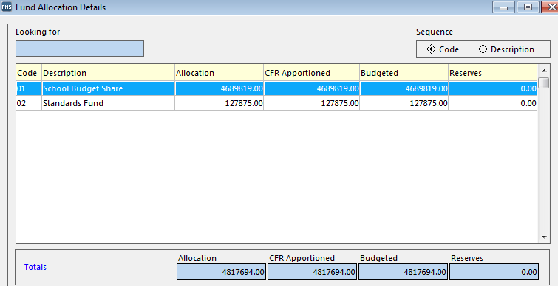

The screen shows a list of the funds that have been set up and the amount of the grant funding is shown under "Allocation".

To enter the Fund Allocations, double-click on the **School Budget Share** to see the screen below.

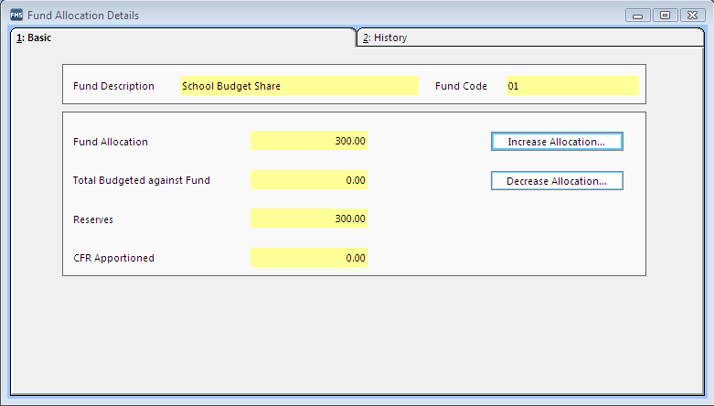

Choose "Increase Allocation" to view a screen similar to below.

On the next screen, enter the amount of funding in the "Increase Allocation by" box and enter a Narrative e.g. Initial Budget.

After entering all the Fund Allocation required, click SAVE.

You should enter all of the grant funding from the Budget Plan with the exception of any amounts that pull through automatically from the Self-Generating Income section which are highlighted in Yellow on the Notes box.

Once you have completed entering the Grant Funding, the total Fund Allocation should agree with the "Budget Allocation Contra" from the Budget Plan which is shown at bottom of Grant Funding section (See Note 2 below)

Note 1 - You do not have enter the Carry Forward from the previous year as a Fund Allocation as this is updated automatically when a Preliminary or Final Close is run in the previous year.

Note 2 - These training notes assume that Other Grant Funding is treated as Self-Generating Income.

**(ii) Allocation of Budget to Cost Centres**

This is to allocate the Budget to Cost Centres i.e the Expenditure and Income Account codes.

The route is **Focus > Budget Management > Cost Centre Allocation**

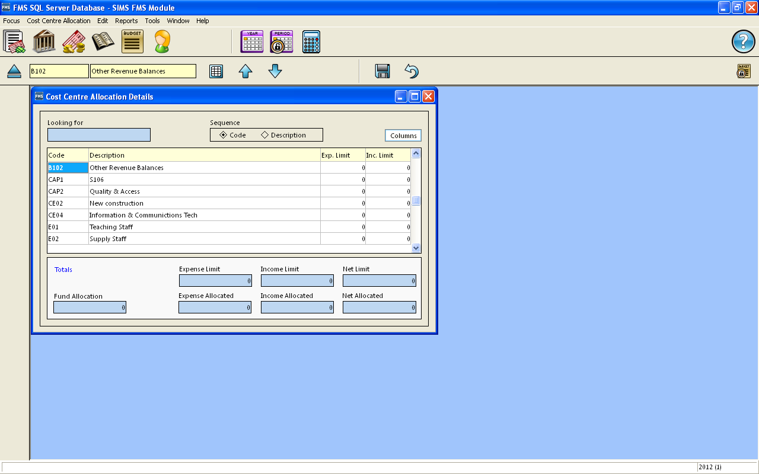

Double click on the appropriate cost centre e.g. E01

This applies to both the Expenditure Codes E01, E02, tec and the Self-Generating Income I08, I10, etc. and Other Grant Funding I03, etc.

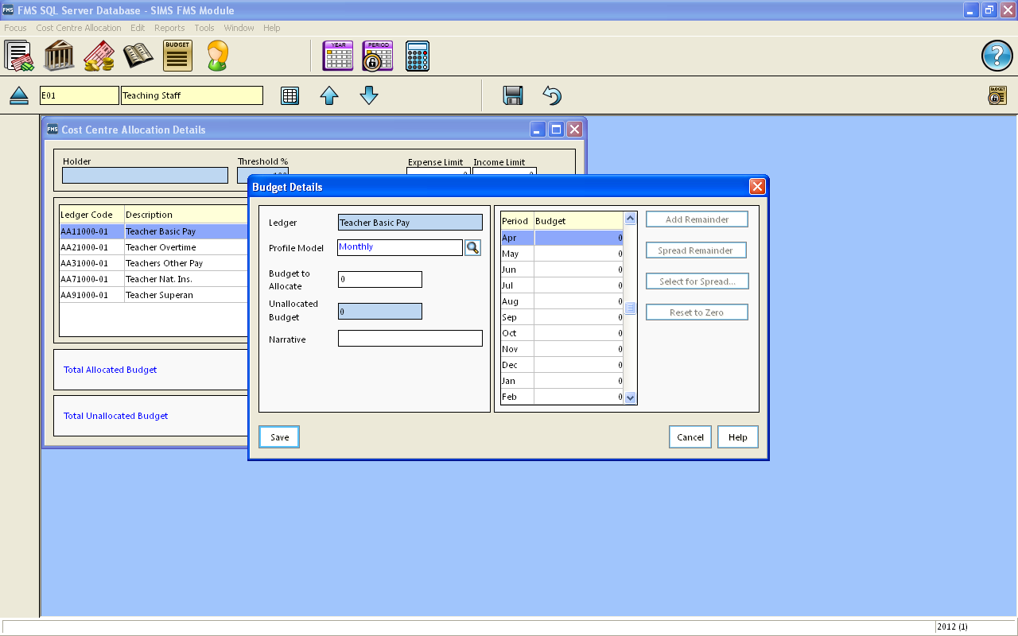

Highlight ledger code e.g. AA1 1000-01 and then click on **pencil icon** to the right of the box to input the details. Input Budgetas per your Budget Plan figure. Put the Budget amount in the "**Budget to Allocate**" box.

Use magnifying glass icon to select **Profile Model** as appropriate e.g. monthly (note the profile option for termly is at the bottom of the list, and you will need to scroll down to access it)

In **Narrative** Boxtype in ‘Initial Budget’ (you can then highlight this text right click and select copy, right click and paste when you need to input this text again later).

Click on **Save**

You may get the following message “the expense budget you are allocating here exceeds the expense budget limit for the cost centre. Do you want the limit to increase automatically ?' click Yes

Select the next ledger code within that cost centre that you want to post to and repeat as required.

Once all ledger codes for that Cost Centre have had the appropriate Budget posted click on the "**Save Record Changes**" Blue Disk icon at the middle top of the screen.

Enter narrative and Save.

Return to first screen, by using the magnifying symbol on the top left of the screen next to Cost Centre info box.

Ensure that you "**Save Record Changes"** regularly throughout the process.

Please note that Income is posted as a positive value on Income codes.

**2. Check Totals**

To check that the totals are correct select **Focus > Budget Management > Fund Allocation** to view the Fund Allocation summary screen (per above).

This screen displays a list of the funds that have been set up along with the Fund Allocation,

Budgeted i.e. how much has been budgeted per the Cost Centre Allocations and how much is left shown as Reserves.

When all the grant funding has been posted to the Fund Allocations and allocated to Cost Centre budgets, the Fund Allocation should equal the Budgeted figure with the Reserves showing as Zero.

**To check Funding Allocations** already posted: Select **Focus > Budget Management > Fund Allocation** and double-click School Budget Share to see screen below.



Choose the 2. History tab which will show a list of all the Fund Allocations that have been posted. You can compare these to the Budget Plan to identify any differences.

The History tab will include an "Opening Balance Journal" entry which is the Carry-Forward balance from the previous year. This is created when a Preliminary Close has been run in the previous year. If the Preliminary Close is run more than once, the system will cancel the previous Opening Balance journal and create a new one with the latest Carry-Forward balance so you may see a number of Opening Balance Journal entries.

**To check the Cost Centre Budget Allocations** run a Cost Centre Summary report to see the totals by CFR reference codes.

Route is Reports > General Ledger > Transactions > Cost Centre Summary Transactions > Cost Centre Summary by Cost Centre.

The Budget is shown in the "Allocated" column which can be reconciled to the Budget Plan.

**3. Changes to Funding during the Year**

When new grant funding is allocated during the year or if the amounts allocated are different to the Initial Budget, then you need to carry out the same process as above for the change in funding i.e Increase or Decrease the Fund Allocation and allocate the budget to a Cost Centre.

The amounts already posted as Fund Allocations can be checked by viewing the History Tab on the Fund Allocation Details screen (as above).

You can Increase or Decrease the Fund Allocations and allocate the budget to a Cost Centre.

**Please note:** When allocating to a Cost Centre you need to input the new total budget not just the increase or decrease.