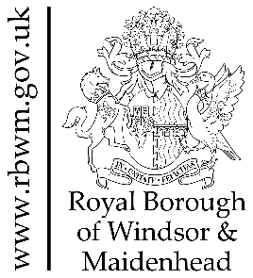
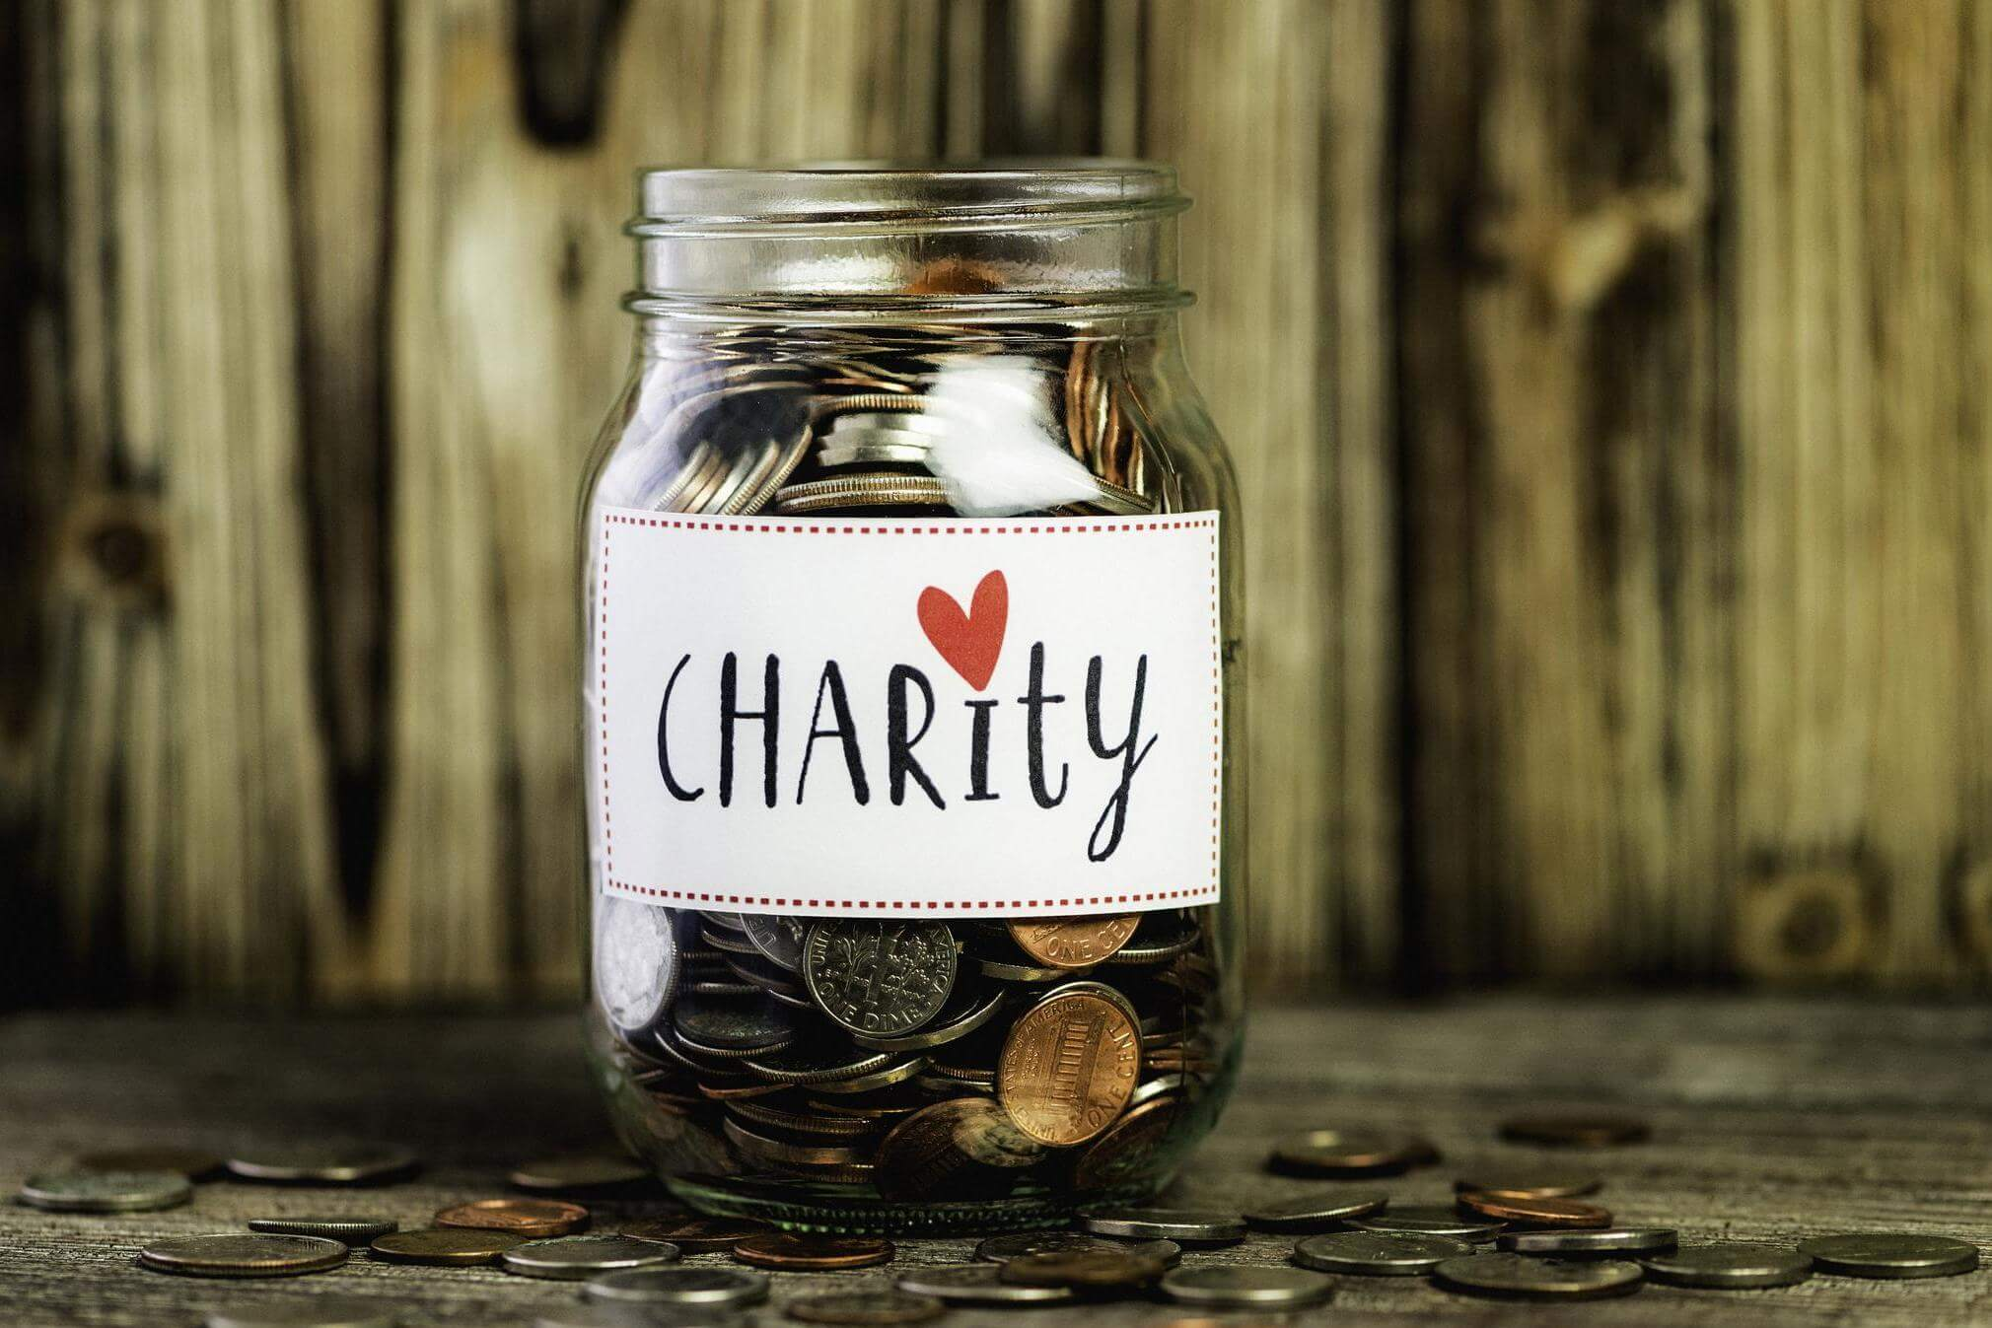

GIVE AS YOU EARN (GAYE) SCHEME

As from August 2021 you can use the Council’s GAYE scheme to make donations to charity. We have chosen Giveall to be our GAYE scheme provider, as they offer a simple on-line system and there is no administration charge, so all of your donation goes to your chosen charity.

How does it work?

You can make a monthly donation from your salary to your chosen charity or charities. As your donation is before tax, the tax man will top up your donation, so your charity benefits from the full amount of your donation. See some examples below:

Monthly donation and amount received by the charity | Cost to 20% taxpayer | Cost to 40% taxpayer | Cost to 50% taxpayer
£5 | £4 | £3 | £2.50
£8 | £6.40 | £4.80 | £4
£10 | £8 | £6 | £5
£15 | £12 | £9 | £7.50

To whom can I donate?

You can donate to any organisation that is a registered charity.

Is there a minimum donation amount?

Yes, the minimum is set at £5 per month.

Can I donate to more than one charity?

Yes, you manage your own Giveall donation account and so can select how you want your donation distributed.

Does RBWM know which charity/charities I am donating to?

No, the Council will only know about the amount you are donating each month.

How do I change my donation?

You just need to log onto your account and make any amendments online by the first of the month and the change will be processed in the next pay run.

One of the good things about payroll giving is that charities have a regular stream of income upon which they can plan their activities, so we would recommend that you don’t change your donations too often, although it is entirely your decision how often you update your donations. For example, you may want to increase your donation on an annual basis if the Council gives a pay award in April.

Are there other ways to manage my donations?

Yes, you can choose to hold all your donations in your Personal Donor Account and then make a one-off payment to your chosen charity/charities.

How quickly does my charity receive my donation?

Giveall processes the payment within two working days of receiving the payment from the Council, which is paid to the Charity on payday every month.

Does the charity know the donation comes from me?

You decide if you want your donation to be anonymous or if the charity receives your donation under your name.

How can I trust Giveall to pay over my donation?

In order to operate a GAYE service, Giveall has been assessed by the HMRC and has been an approved provider since 2011.

How do I sign up?

You need to set up your own account by using the Council’s PAYE reference number – 070PA00150569

Select RBWM and register as a new user, you will get an activation code to the email address you have registered. Then select Payroll type – monthly and enter your Payroll/Personal ref number. You can find this on your payslip. Then you can select your charity or charities or opt to save your donations in your personal account. Then add the amount per month that you want to donate. It’s as easy as that.

I have other questions.

Refer to this information on the Giveall website, their FAQ's or email pay.benefits@rbwm.gov.uk

